**Assignment on Digital Marketing**

**Name: C. VIGNESH**

**NAAN MUDHALVAN ID: 8D6A97B32191496BECE4F341F46CA3E7**

* **Create a blog or website using Blogspot and WordPress. Customize the theme design and post new article with 500 words.**

**WORDPRESS**

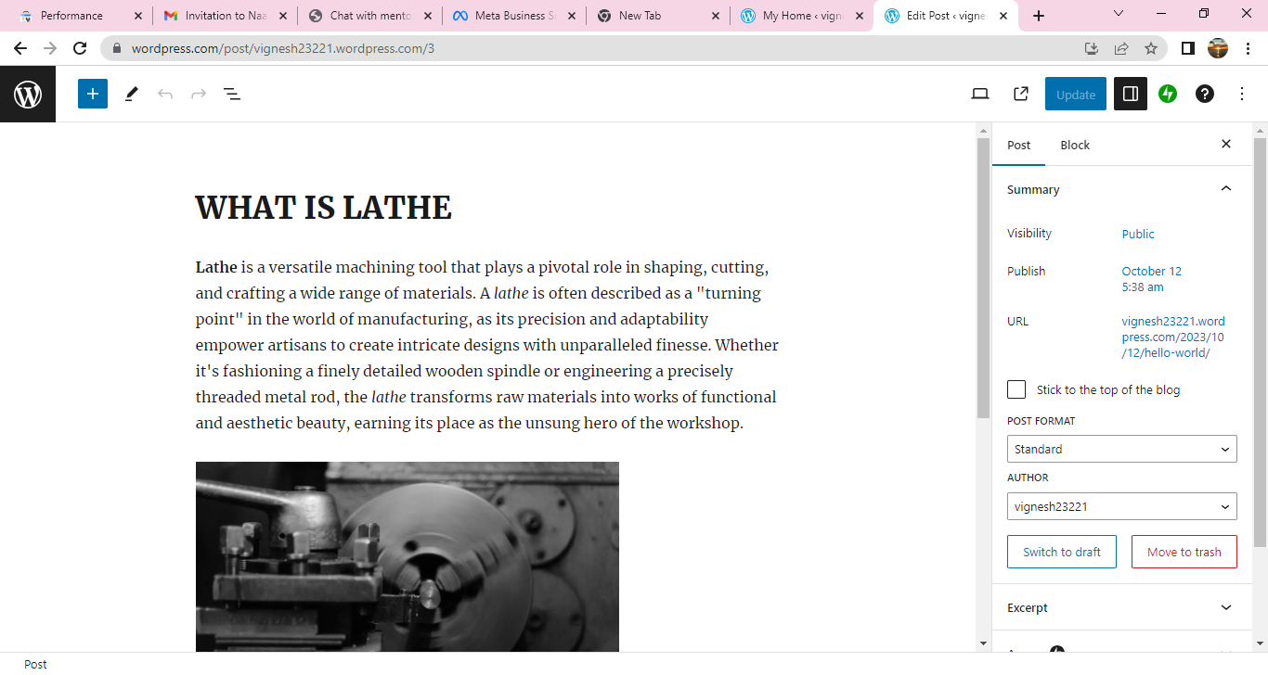

**Hyperlink :**[**https://vignesh23221.wordpress.com**](https://vignesh23221.wordpress.com)

* **Create a New Facebook Business Page and post one social media poster for your brand**

**FACEBOOK BUSINESS PAGE**

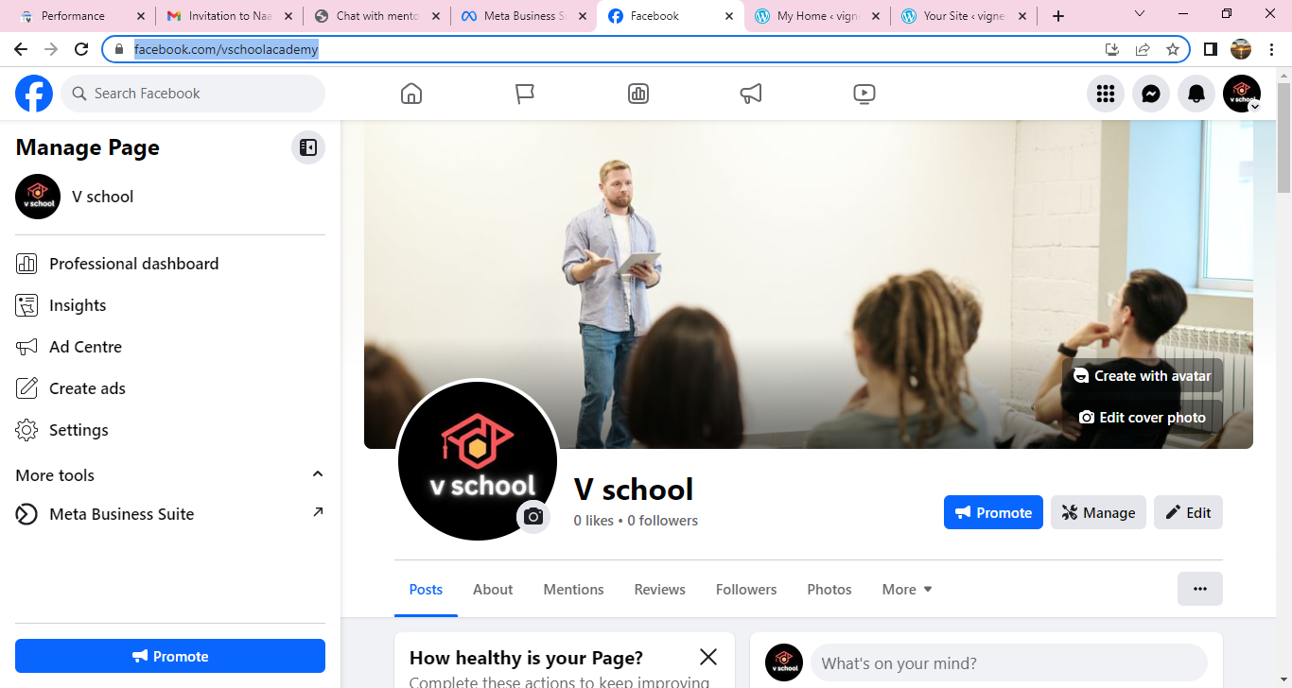

**Hyperlink:**[**https://www.facebook.com/vschoolacademy**](https://www.facebook.com/vschoolacademy)

* **Create and design a social media advertisement poster using canva**

**CANVA ADVERTISEMENT POSTER**

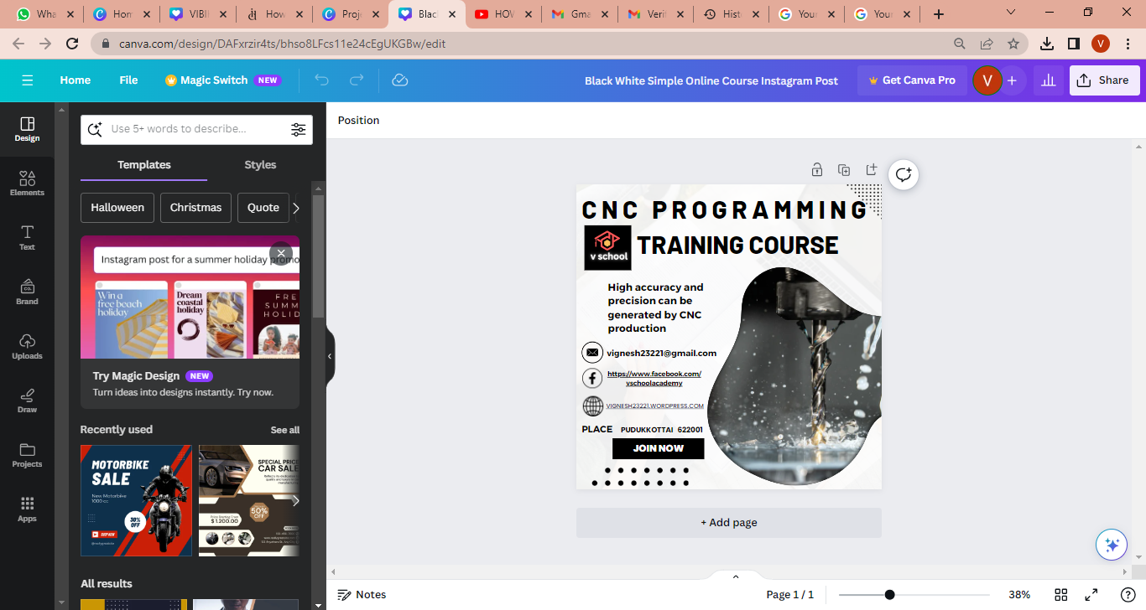

**Hyperlink:**[**https://www.canva.com/design/DAFxrzir4ts/VePLRRnDZ_d_zXx36Bk85Q/view?utm_content=DAFxrzir4ts&utm_campaign=designshare&utm_medium=link&utm_source=editor**](https://www.canva.com/design/DAFxrzir4ts/VePLRRnDZ_d_zXx36Bk85Q/view?utm_content=DAFxrzir4ts&utm_campaign=designshare&utm_medium=link&utm_source=editor)

* **Create email newsletter design using MailChimp or canva tool**

**CANVA**

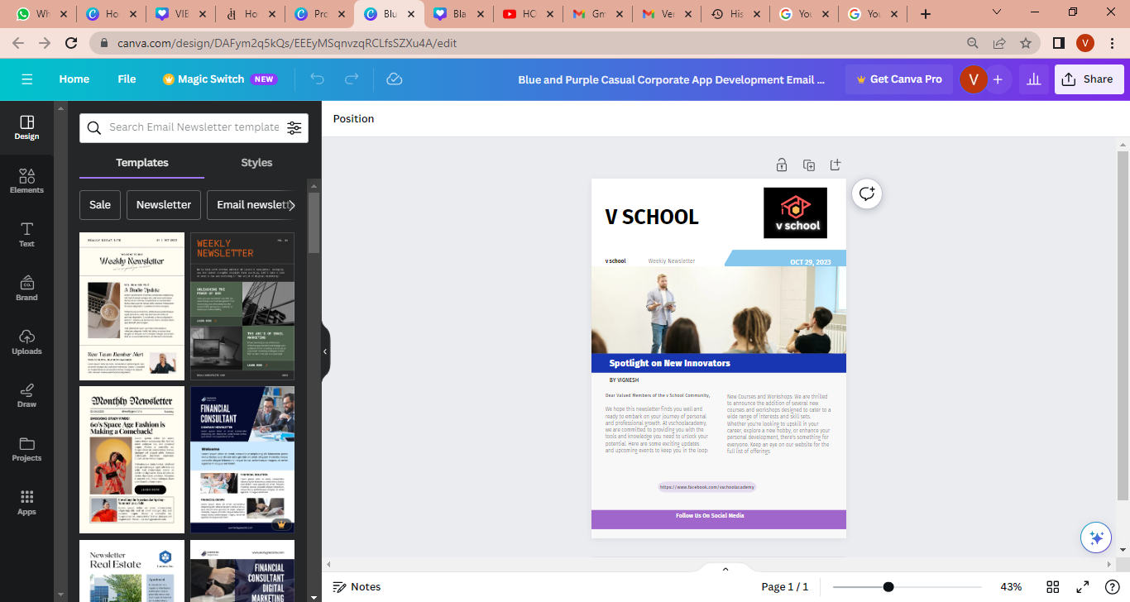

**Hyperlink:**[**https://www.canva.com/design/DAFym2q5kQs/Iji-04oODyIB2rsA3EE4UQ/view?utm_content=DAFym2q5kQs&utm_campaign=designshare&utm_medium=link&utm_source=editor**](https://www.canva.com/design/DAFym2q5kQs/Iji-04oODyIB2rsA3EE4UQ/view?utm_content=DAFym2q5kQs&utm_campaign=designshare&utm_medium=link&utm_source=editor)